**[](http://www.ricgroup.com.au/product/conflict-resolution/)**

**[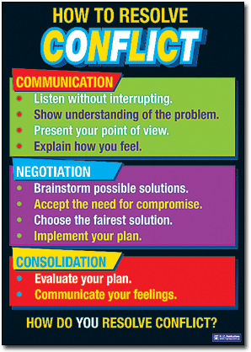](http://www.ricgroup.com.au/product/conflict-resolution/)**

[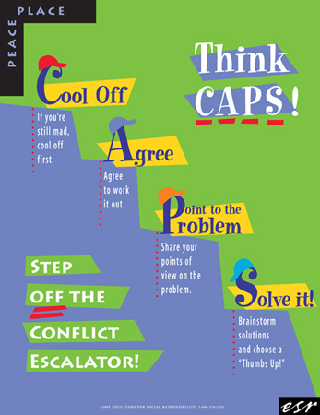](http://www.google.com/url?sa=i&rct=j&q=&esrc=s&source=images&cd=&cad=rja&uact=8&docid=vTTC99-n5l9HOM&tbnid=JrBFbndmlziCgM:&ved=0CAUQjRw&url=http://www.esrnational.org/store/index.php?main_page=product_info&products_id=78&ei=u-mZU626O8-1yASMgIH4Cg&psig=AFQjCNFcWsGkF7MBrnvCfdU5z8Bq5zMPlQ&ust=1402682131309049)

****[](http://www.google.com/url?sa=i&rct=j&q=&esrc=s&source=images&cd=&cad=rja&uact=8&docid=XaB902AqbuEvuM&tbnid=T6m1AXmFHtqc9M:&ved=0CAUQjRw&url=http://www.bloglovin.com/en/blog/5190739&ei=tuyZU9HQNcKYyATx9IDAAg&bvm=bv.68911936,d.aWw&psig=AFQjCNHybZTqU44N8y5XC9vYnkBjS9ln9A&ust=1402682926776108)[](http://www.google.com/url?sa=i&rct=j&q=&esrc=s&source=images&cd=&cad=rja&uact=8&docid=C5pYlMjT3F9GgM&tbnid=srjnJG7ty8zxvM:&ved=0CAUQjRw&url=http://www.cleartalkmastery.com/what-we-do/&ei=qe2ZU8OTMIybyATujYKYCw&bvm=bv.68911936,d.aWw&psig=AFQjCNEkHEyu_a6pG5CY0h7e1ZJIFZsGYg&ust=1402683139985433)[](http://www.google.com/url?sa=i&rct=j&q=&esrc=s&source=images&cd=&cad=rja&uact=8&docid=C5pYlMjT3F9GgM&tbnid=srjnJG7ty8zxvM:&ved=0CAUQjRw&url=http://www.cleartalkmastery.com/what-we-do/&ei=qe2ZU8OTMIybyATujYKYCw&bvm=bv.68911936,d.aWw&psig=AFQjCNEkHEyu_a6pG5CY0h7e1ZJIFZsGYg&ust=1402683139985433)

**Solve the**

**problem**

**Talk it out**

**Calm down**